**Terraform Task-1**

Launch Linux EC2 instances in two regions using a single Terraform file.

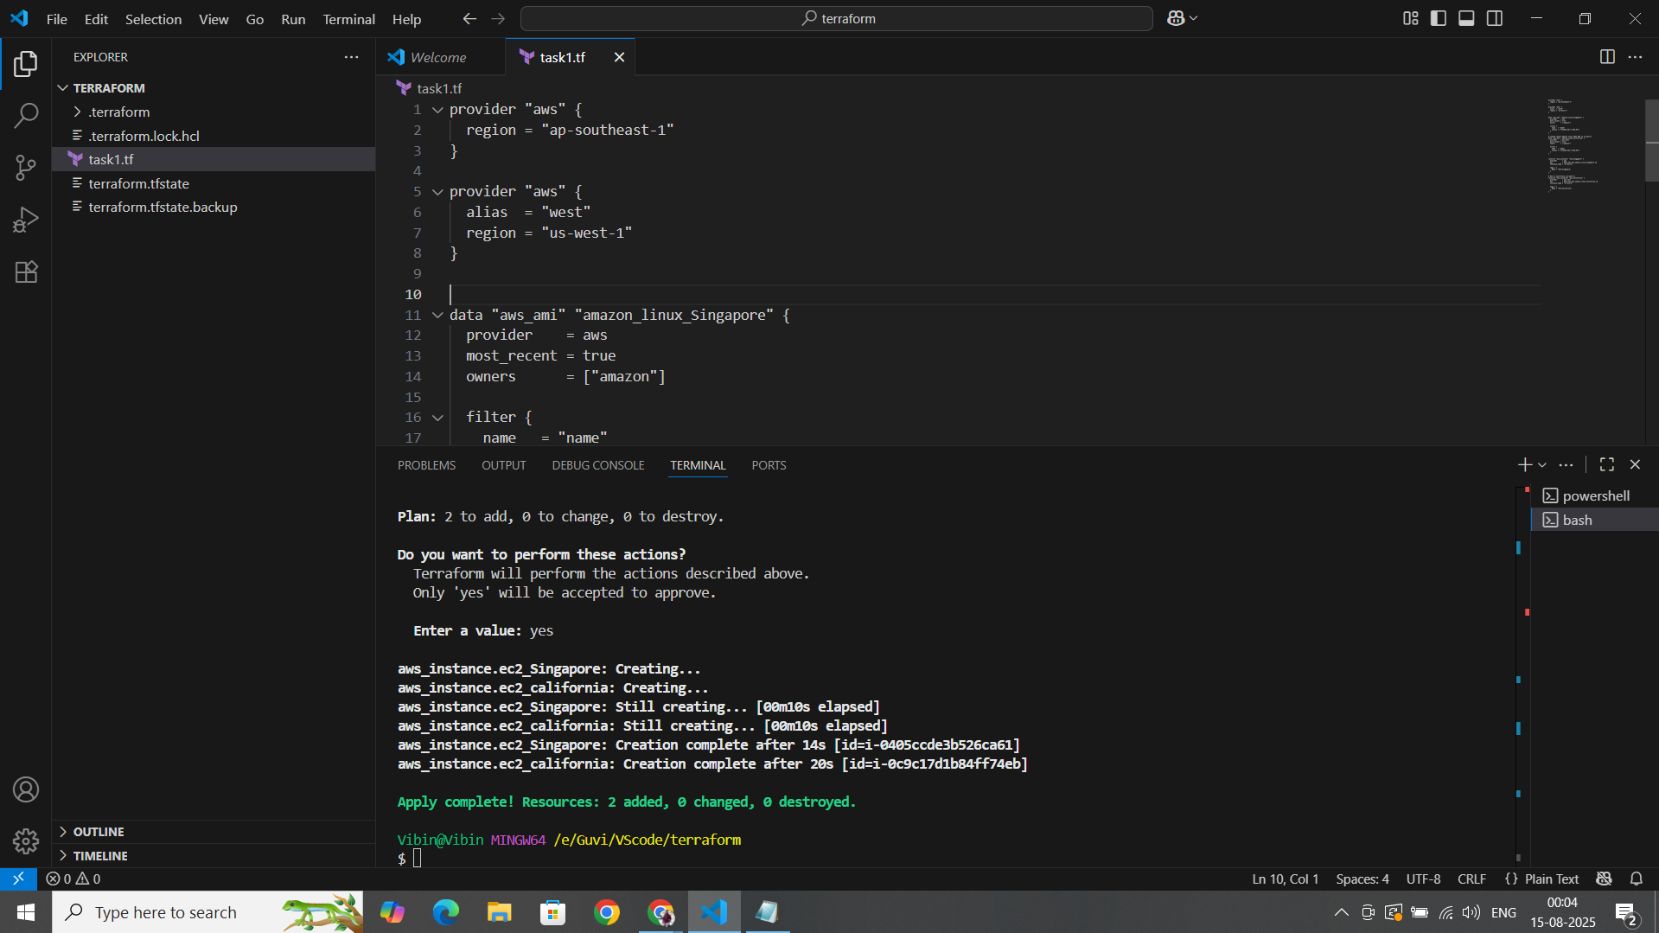

**EC2-Region-2**

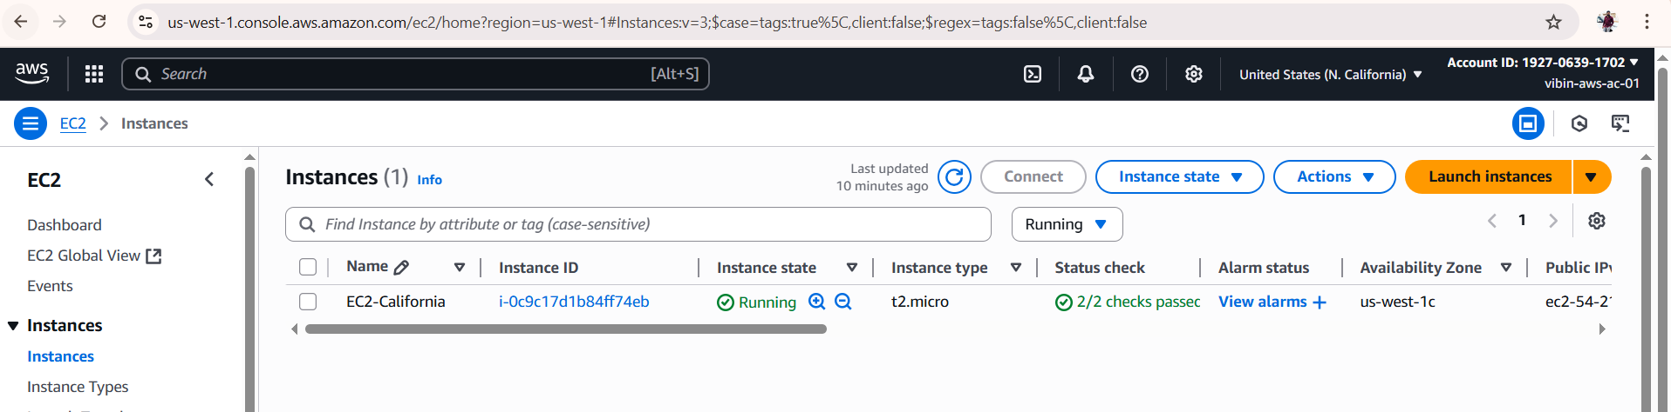

**EC2-Region-2**

